DEPARTMENT B FOODS

PREMIUMS: FIRST - $5.00; SECOND - $3.00; THIRD - $2.00

RULES
- Baked goods must be displayed on rigid disposable plates and covered with clear re-sealable plastic bag.
- All canned products and pickles must be in clear glass regulation canning jars and properly sealed. Canned products not in regulation jars (i.e. mayonnaise, peanut butter, pickle, etc.) will not be accepted. No paraffin on jelly.
- Jellies, jams, preserves and pickles may be opened for judging.
- Rings must be on jars.
- General Rules and Regulations apply.
- The Ball Blue Book recommendations will be used as the criteria when determining if a product is accepted for judging.
- Baked goods that become visually unattractive will be discarded.
- No canned foods will be accepted with rust on lids or rings.
- Canned products not sealed will not be accepted for entry.
- Canned foods judged on appearance only. Judges will not taste canned
foods.

SECTION I – BREADS
PREMIUMS: FIRST - $5.00; SECOND - $3.00; THIRD - $2.00

Standards

LOOKS: tender and good, even, golden brown color, good shape
TEXTURE: fine, even grain, small thin cell walls, light for size, crisp crust
CRUMB: creamy white, slightly moist, light and elastic, tender
FLAVOR: good, well-blended flavor, pleasing

CLASS
- Three rolls
- Light loaf bread (½ loaf)
- Quick sweet bread (½ loaf or whole small loaf)
- Yeast sweet bread (½ loaf or 3 rolls)
- Three biscuits
- Cornbread – two pieces
- Cornbread – muffins or sticks (2)
- Muffins (2)
- Sourdough (½ loaf)
- Scones
- Anything made from canned biscuits

SECTION II – SPECIAL BREAD CATEGORY (½ LOAF)

FIRST - $15.00; SECOND - $10.00; THIRD - $7.00

All entries in this category must be made from the following recipe contributed by Mrs. Kenton Chittum.

2 tablespoons shortening 1 cup scalded milk
1 cup boiling water 1 yeast cake softened in
2 tablespoons sugar ¼ cup lukewarm water
2 teaspoons salt 6 to 6½ cups all-purpose bread flour

Put shortening, sugar and salt in a large bowl without a lid, or in top of large double broiler. Add liquids. Cool to lukewarm. Add yeast. Stir in 3 cups of flour. Mix thoroughly. Add 2 cups of flour, mix and add remaining flour gradually, using just enough to prevent sticking to the bowl.

Put the last ½ cup of flour on the mixing board or cloth and use some of it to dust the board very lightly, pushing the rest aside to work into the dough, if you need it. Turn the ball of dough out onto the board, leaving a clean bowl. Cover and let “rest” 10 minutes, which makes the dough easier to work with.
Knead, let rise, punch down and shape. Let rise until double in bulk (about one hour) and bake. Bake at 375° for 15 minutes and lower oven temperature to 350° and continue baking for 25 to 30 minutes. Your loaf should have a hollow sound when “plunked” on the top.

SECTION III – SPECIAL CAKES (½ Cake)

PREMIUM: FIRST - $15.00; SECOND - $10.00; THIRD - $7.00

- All entries in this category must be made from a Dolly Parton Banana cake mix.
- It may be changed any way desired by cook other than the quantity.
- Cake will be judged on originality, taste, and appearance. Any frosting or filling may be included.
- Recipe must be submitted with entry.

SECTION IV – THEME CAKE – “COUNTRY ROOTS & COWBOY BOOTS”

PREMIUM: FIRST - $20.00; SECOND - $15.00; THIRD - $7.00

1. Entries may be from scratch or boxed mix.
2. Entries may exhibit theme both inside and outside of cake
3. Entries will be cut
4. Cake will be judged on originality, taste, and appearance. Any frosting or filling may
be included.

SECTION V – SPECIAL ROLLS (Refrigerator Rolls)

PREMIUM: FIRST - $15.00; SECOND - $10.00; THIRD - $7.00

3 Rolls on Paper Plate in Plastic Bag

INGREDIENTS

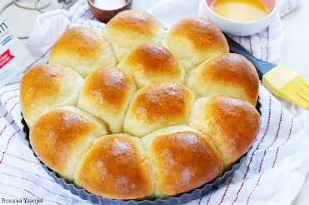
¾ C Hot Water

½ C Sugar

1 Tablespoon Salt

3 Tablespoons Margarine

1 C Warm Water

2 Packs dry yeast

1 Egg

5 ¼ C Sifted Flour

Mix hot water, sugar, salt, margarine; cool until luke warm. Measure warm water into large bowl; sprinkle in yeast; stir until dissolved. Stir in lukewarm mixture, egg and 3 cups flour. Beat until smooth. Add the rest of the flour, mixing well. Place dough in greased bowl and brush top with soft margarine. Cover tightly with waxed paper or aluminum foil.

Refrigerate until doubled in bulk or until needed (4 days). To use pinch down, cut off the amount of dough required and form favorite shapes. Cover: let rise in warm draft-free place until doubled in bulk, about 1 hour. Brush with melted margarine. Bake in 400-degree oven about 10-15 minutes or until done.

SECTION VI – ALL-AMERICAN APPLE PIE CONTEST

PREMIUM: FIRST - $100.00; SECOND - $50.00; THIRD - $25.00

Take in for PIES will be at 2:00 p.m on Saturday, September 16, 2023

Judging will be held at 3:00 p.m on Saturday, September 16, 2023

PIES will be taken at main exhibit building (A)

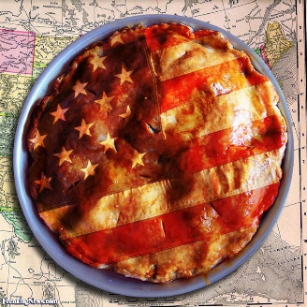
1. 9 – 10-inch round PIE

2. Entries must be made from scratch. (Crusts and filling)

3. PIE will be judged on originality, taste and appearance.

4. Recipe must be submitted with entry.

SECTION VII – VIRGINIA EGG COUNCIL CONTEST

The Five Star Dessert Bars Recipe Contest sponsored by The Virginia Egg Council judging will be held on Sunday, September 10, 2023 at 4:00 p.m.
Please see additional information and bring with you the entry forms that are available at https://virginiaeggcouncil.org/events.cfm
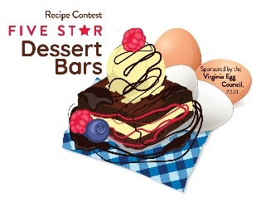
- The recipe must include a minimum of four large whole eggs.
- Entrant must prepare a recipe for desert bars, baked in a traditional 9X13” baking pan. Desert bars should be sliced and presented on a plate or platter for judging.
- Ingredients must be listed in the order of use.
- List ingredients in order of use; include clear preparation instructions, cooking time and temperatures, pan size and yield.
- The legible recipe must be on one side of page and must be submitted with prepared entry
- Back side of page must include contestant’s name, address, phone and email address and the name of the item.
- Recipes will be prepared and presented for judging.
- Contestants must fil in a participant Release Form, to be attached to recipe.

The top three winning recipes get special gifts from the VA Egg Council AND become eligible to compete in the Five Star Dessert Bars Contest Finals To be held at the State Fair of Virginia, September 30, 2023

Prizes at STATE Level on September 30, 2023
1st - $400 plus 1 dozen Eggland’s Best Eggs each week for 1 year
2nd - $300 plus 1 dozen Eggland’s Best Eggs a week, for 6 months
3rd - $200 plus 1 dozen Eggland’s Best Eggs a week for six months

SECTION VIII - CAKES

PREMIUMS: FIRST - $10.00; SECOND - $7.00; THIRD - $5.00

Standards: Level or slightly rounded and uniform in thickness, light, tender, fine and uniform grain. Slightly moist Icing – smooth texture, good flavor and appropriate for cake. This does not apply to decorated cakes. No mixes.

CLASS
- Pound or chiffon cake – ½ cake
- Decorated cakes – Appearance only. Mock forms may be used. Will not cut or taste.
- 4 cake pops – displayed on form/covered.

SECTION IX – PIES

PREMIUMS: FIRST - $10.00; SECOND - $7.00; THIRD - $5.00

CLASS
- Fruit Pie (For example, fruit, cherry, apple, peach, etc.)

2. Fried Pies (same list as above)

3. Tarts

SECTION X – COOKIES

PREMIUMS: FIRST - $5.00; SECOND - $3.00; THIRD - $2.00

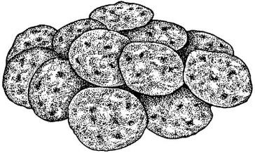
CLASS
- Brownies – three
- Other Bar Type Cookies – three
- Dropped Cookies - three
- Pressed or Shaped – three

COOKIE JAR CONTEST

This category is a jar of assorted cookies. Jar may be any kind of wide-mouthed, transparent jar; decorated as desired.
Premiums – 1st place - $30, 2nd place - $25, 3rd place $15
Criteria
- Jar presentation is 50% of judging
- Cookies will account for 50% of judging
- Jar not less than 6 inches, but no more than 15 inches in height
- 15 inch maximum does not include decorations
- Minimum of three (3) types of cookies
- Cookies must be made by exhibitor
- For judging purposes - One of each cookie must be submitted for judging singularly in a zip-loc baggy, labeled with entry tag on a disposable plate
- Placement awards given at judge’s discretion based on above criteria

SECTION XI – CANDY

PREMIUMS: FIRST - $5.00; SECOND - $3.00; THIRD - $2.00

Smooth consistency, free of crystals, characteristics of type.

CLASS
- Assortment – three varieties, two of each
- Chocolate fudge – three pieces
- Peanut butter fudge – three pieces
- Mints – three pieces
- Divinity and Sea foam – three pieces
- Miscellaneous – three pieces

SECTION XII– CANNED FOODS

PREMIUMS: FIRST - $5.00; SECOND - $3.00; THIRD - $2.00

CLASS

- Apple jelly
- Crabapple jelly
- Blackberry jelly
- Grape jelly
- Raspberry jelly
- Hot pepper jelly
- Miscellaneous jelly
- Peach preserves
- Strawberry preserves
- Miscellaneous preserves
- Blackberry jam
- Raspberry jam
- Strawberry jam
- Miscellaneous jam
- Apple butter – crock pot
- Apple butter – long cooked
- Whole sweet cucumber pickles
- Cubed sweet cucumber pickles
- Sliced sweet cucumber pickles
- Whole sour cucumber pickles
- Sliced sour cucumber pickles
- Dill pickles
- Pickled Peppers
- Squash or Zucchini pickles
- Dilly beans or okra
- Bread and Butter pickles
- Miscellaneous pickled vegetables
- Cucumber relish
- Chow-Chow
- Pepper relish
- Miscellaneous relish
- Pickled beets
- Sweet potatoes
- Green beans (cut)
- Corn
- Whole tomatoes
- Stewed tomatoes
- Tomato juice
- Tomato sauce
- October beans
- Miscellaneous pepper
- Kraut (jars must be sealed)
- Soup mixture
- Miscellaneous vegetables
- Apples
- Applesauce
- Pears
- Peaches
- Grape juice
- Miscellaneous fruit
- Molasses and syrups
- Spaghetti Sauce
- Sauce (Ketchup, Barbeque, hot, etc)
- Dehydrated fruit or vegetables
- Salsa
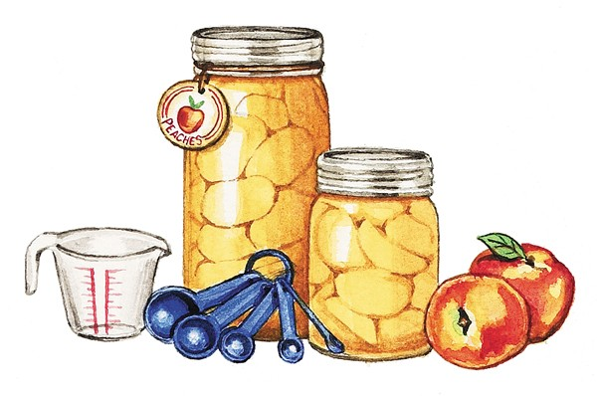
- Meats
- Dried herbs

