FARM CROPS

COMMITTEE: Phil Blevins and Lisa Little

GENERAL RULES:
- All field crops, tobacco, and vegetables must be entered in the name of the producer on SUNDAY, SEPTEMBER 10, 2023 between the hours of 2:00 p.m. and 5:00 p.m.
- Entries must be removed on SUNDAY, SEPTEMBER 17th between the hours of 1:00 p.m. and 3:00 p.m.
- Only one entry per exhibitor in any class and all products must be of the current years’ growth.
- In any class where there is no competition, a blue ribbon will be awarded (if worth) and second money paid.
- Any exhibit that deteriorates during the week may be discarded. Premiums will still be awarded and ribbons will be displayed.
- Any person entering 10 items will be awarded a one-day pass to the Fair. Weekly passes will be given to Best of Show winner in each department.
- Best of Show winners need to pick up weekly passes at main gate on Monday of the fair.

DEPARTMENT A FIELD CROPS AND VEGETABLES
PREMIUMS: FIRST - $5.00; SECOND - $3.00; THIRD - $2.00

SECTION I – OPEN

- Yellow or White Corn Stalks with ear – 3 stalks
- Yellow or White Corn – 3 ears (shucked but shuck attached to ear)
- Popcorn, any variety – 3 ears
- Ornamental Corn – 3 ears
- Irish Potatoes – 3 specimens
- Irish Potato – largest – 1 specimen
- Sweet Potatoes, 3 specimens
- Red tomatoes, table type, slicing – 3 specimens
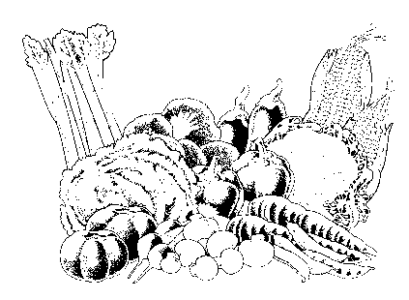
- Yellow tomatoes, table type, slicing – 3 specimens
- Small novelty tomatoes – 6 specimens
- Peppers, sweet bell – 3 specimens
- Peppers, banana – 3 specimens
- Peppers, hot – 3 specimens
- Green Beans, snap – 6 specimens
- Pole Beans – 6 specimens
- October Beans – 1 pint
- Beets with tops – 3 specimens
- Broccoli – 1 bunch
- Carrots, with tops – 3 specimens
- Chicken Eggs (1 dozen in carton)
- Chestnuts – 5 specimens
- Sweet Corn, untrimmed, in shuck – 3 ears
- Cucumber, slicing – 3 specimens
- Cucumber, pickling – 3 specimens
- Yellow onion – 3 specimens
- Red Onions – 3 specimens
- White Onions – 3 specimens
- Pumpkin, any variety, good quality – 1 specimen
- Pumpkin, largest – 1 specimen
- Pumpkins, Jack-O-Lantern Type – 1 specimen
- Squash, any variety, good quality – 1specimen
- Gourd, ornamental display – 3 or more
- Gourd, large type – 1 specimen
- Okra – 3 pods
- Squash, winter type – 1 specimen
- Summer squash – 3 specimens
- Grapes – 3 bunches
- Sunflower, good quality, 1 head
- Vegetable plate, exhibitor’s choice – 5 or more specimens
- Watermelon – 1 specimen
- Cantaloupe – 1 specimen
- Honey with comb
- Honey strained
- Miscellaneous
- Hay, alfalfa – 1 bat in clear plastic bag
- Hay, orchard grass – 1 bat in clear plastic bag
- Hay, Timothy – 1 bat in clear plastic bag
- Hay, mixed grass – 1 bat in clear plastic bag

SECTION II – YOUTH

Classes same as above for youth under 18 as of day of show.

PREMIUMS (to be paid in addition to ribbons):

FIRST - $5.00; SECOND - $3.00; THIRD - $1.00

DEPARTMENT B BURLEY TOBACCO

PREMIUMS (to be paid in addition to ribbons):

FIRST - $25.00; SECOND - $15.00; THIRD - $10.00; FOURTH - $5.00


CLASS
- Stalks, 3 green, 2022 crop – Fresh cut

